Press Release September 2022
A New Era for Aran Woollen Mills as the Next Generation of the Hughes Family launch their First Direct-To-Consumer Website
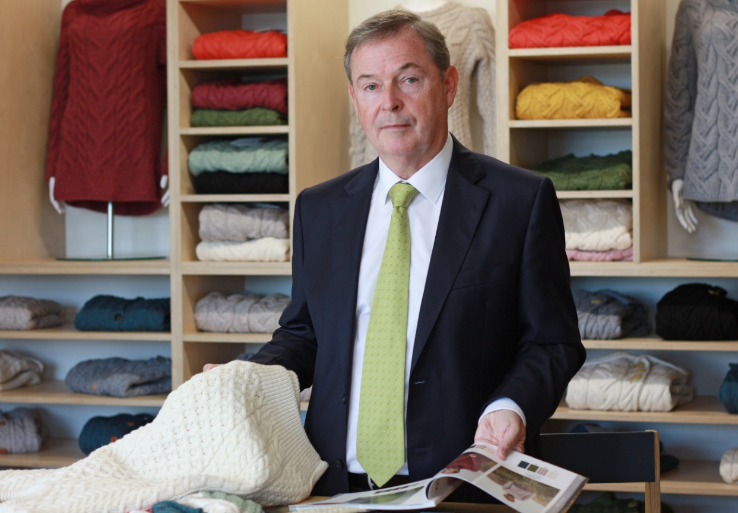

Mrs. Maire Hughes’ determination to find a way to harness and sustain local employment in Westport, County Mayo and bring premium, heritage Aran products from ‘Westport to the World’, has been the driving force behind Aran Woollen Mills since she founded the company in 1965. Her vision has been realised by her children, in particular her sons and current owners of the business, Vincent and Patrick Hughes. Today the company is proud to be the design-led global leaders in the manufacturing of made in Ireland traditional and contemporary Aran knitwear. This September Aran Woollen Mills will launch the first capsule collection under their own brand, available directly through a new dedicated e-commerce website.
Manufacturing for trade, wholesale and white label garments since its inception, Aran Woollen Mills has been swift to adapt to the dynamic marketplace that has changed rapidly over recent years, embracing technology, innovation, people and the digital era. This adaptability has meant that it is one of the few textile companies thriving, designing, and manufacturing collections in the west of Ireland. The pandemic accelerated the consumer shift to e-commerce nearly overnight and has seen consumers become more conscious of where their purchases, particularly fashion, are coming from. By expanding the business with the further development of their own brand alongside their existing manufacturing services, Aran hopes to allow them to really connect with a new audience, provide consumers with sustainable garment options and highlight the history and people of County Mayo both at home and around the world.
As a design-led manufacturing company, this further development of their own brand will allow Aran to become more agile with their product and product development for trade as well as consumer. The smaller capsule collections will allow them to trial new designs and gain consumer feedback before bringing the products to trade, minimising the chances of the production of surplus stock. An adaption that will positively impact both finances and the environment.
We hold the tradition of Aran knitting close to everything we design and produce while also understanding that consumers want newness, product diversification as well as the changing consumer needs and expectations. As a business we have constantly developed and innovated over the years, from experimenting with colours, to developing new and exciting yarn mixes such as our super-soft yarn. We are excited to be able to explore this new route to market, offering consumers premium sustainably made garments while continuing to create skilled jobs in the west of Ireland and keeping the heritage of Aran knitting well and truly at the forefront of Irish retail exports for many years to come.’ Vincent Hughes, Owner, Aran Woollen Mills.
To support the company’s expansion and to support the development of their own brand, Aran has continued to invest in skilled jobs across Mayo and top of the range technology. Currently providing 100 jobs in the area, the opening of a new manufacturing facility in Belmullet Co. Mayo in 2021 combined with a second factory which will be up and running by late 2022, the county will see up to 50 new jobs created by 2023. This process, Vincent explains would not have been possible without the support they received from the local community and organisations. ‘The local support we received in establishing our facility in Bellmullet has been invaluable. Without the help of the like of Údarás na Gaeltachta, who we worked closely with to establish a new manufacturing footprint in the area, and the terrific support given to us by businesses such as Brogans of Bellmullet who facilitated our lease, the company’s future expansion would have been a much lengthier process’
The new website marks a new and exciting chapter for the Aran Woollen Mills brand. Enterprise Ireland have supported the business on their digital journey over the last 18 months. “We are incredibly grateful for the support we have received from Enterprise Ireland in supporting the implementation of our digital expansion. As a brand we are excited to showcase and highlight the unique heritage, quality and the natural and sustainable yarns that are used in our garments, bringing quality heritage lifestyle pieces to today’s consumer both at home and abroad. This journey will take our business to the next level and allow Aran sweaters to be viewed through a more modern lens. Aran knitwear is much more than a tourism product and we want to help our customers showcase all the benefits of Aran knitwear to the world stage.” Vincent Hughes, Owner, Aran Woollen Mills.

Aran Woollen Mills’ will Launch their new Direct to Consumer Website on 22nd September 2022 and introduce their first capsule collection under the Aran Woollen Mills Brand. For more Information, please visit their trade website: www.aranwoollenmills.trade

For press enquiries, please contact Katie Stafford Noonan, katie@revolve.ie , M: +353 87 907 3791
Revolve Marketing & PR, 23 The Crescent, Monkstown, Co. Dublin, Ireland, A94 X960
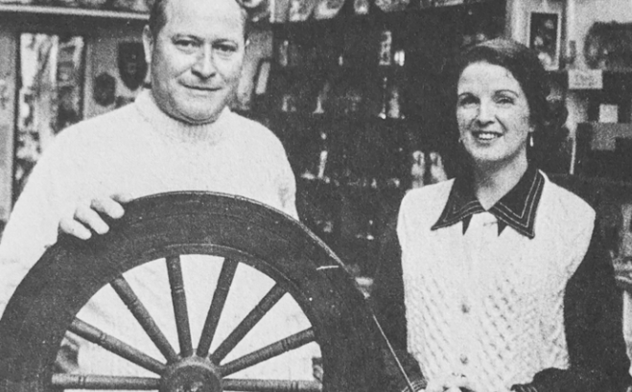

- ENDS -
Notes to Editor

About Aran
Aran Woollen Mills was founded in Westport, Co Mayo in 1965 by local couple Maire and Padraig Hughes and has grown to become Ireland’s largest home -based Aran knitwear manufacturer. She established the business to follow her passion for Irish craft, heritage and to provide employment locally in the West of Ireland, a legacy which continues today as Aran Woollen Mills continues to Design and Manufacture in Co. Mayo. Today, the Hughes family continue to develop and grow the business internationally.
Their first major customers were craft shops on the West and South coast of Ireland and in Dublin. They also began to export which had been part of their plan from the beginning. ‘From Westport to the world’.
Being a manufacturing house, as well as a brand, Aran Woollen Mills takes enormous pride in their authentic Irish knitwear and accessories ranges that are manufactured here in Ireland to the highest standard. By using the best natural materials and a skilled workforce the resulting genuine, premium quality Irish products have passed through rigorous quality control checks throughout the manufacturing process from design to production. Streamlined processes allow for efficient and effective distribution to customers across the globe.
Aran Woolen Mills remains a family business with family values. Many employees have been with company for over 30 years, some over 40, who alongside Hughes Family members, who worked tirelessly to start and build the business. Their legacy lives on in Aran Woollen Mills and the family, led by Maire and Padraig’s son and current owner Vincent Hughes, are committed to the future success of the business, maintaining, and growing skilled jobs in the west of Ireland while keeping the heritage of Aran knitting well and truly at the forefront of Irish retail exports for many years to come.
In 2021 Aran Woollen Mills opened a new Manufacturing facility in Belmullet Co. Mayo. This facility will be joined by a second by the end of 2022. Combined, these two facilities will see up to 50 new jobs created in the area by 2023 in addition to the 100 staff already employed by the company.

www.aranwoollenmills.trade

Vincent Hughes
The son of Maire and Padraig Hughes’ 13 children, current owner of Aran Woollen Mills, Vincent has been involved in the family business since its inception and by the time he was 20, had amassed a wealth and knowledge of customer service experience, business acumen, design and manufacturing expertise far beyond his years.
After qualifying with a Diploma in Textile and Knitwear Technology, Vincent worked in industry for several years before returning to the family business in 1981 to develop and concentrate on innovating the family’s knitwear manufacturing business.
Vincent introduced a selection of colours to the range in 1981, natural yarn having been the only option prior to this. Both Vincent and his brother Patrick worked together setting up a new manufacturing plant and distribution facility using the knowledge and skills they had built up over the years. New electronic machines and design programmes were introduced which increased production, additional staff were recruited, and new administration and distribution systems were established. Every few years the knitting machines are updated to ensure optimum efficiency, safety and to address future capacity, whilst always maintaining the authentic significance and heritage of the Aran knitting, which lies at the heart of the business.

Natural Yarn
Aran Woollen Mills manufacture high quality, premium, knitwear made from responsibly sourced natural fibres. These natural fibres provide many benefits - they are anti-microbial, odour repellent, water and dirt resistant, the yarn wicks away moisture from the body, the yarn has superior insulating properties, making them warm in the winter and cool in the summer.
Animal welfare is paramount to our business – it underpins everything we stand for. We buy our wool from yarn suppliers who work closely with small, family sheep farmers. Every single animal is very important to the farmers’ livelihood, so the sheep are particularly well cared for. These farms tend to be passed down the generations. The wool is cleaned, combed, dyed, and spun in the country of origin, usually as part of a community programme, the yarn suppliers being officially recognised, before it arrives on the cone here in Ireland, ready to be inspected before it is knitted

Údarás na Gaeltachta
Údarás na Gaeltachta has a dedicated team working in five Regional Offices and covering all seven Gaeltacht regions offering a range of support services at local, regional, and national levels and implementing the organisation’s functions in enterprise development and job creation, promotion of the Irish language and culture, and community development.
Údarás na Gaeltachta’s overall objective is to ensure that Irish remains the main communal language of the Gaeltacht and is passed on to future generations. The Údarás endeavours to achieve that objective by funding and fostering a wide range of enterprise development and job creation initiatives and by supporting strategic language, cultural and community-based activities. For more information, please visit https://udaras.ie/en/ .

Aran Woollen Mills are on Social

LinkedIn:
https://www.linkedin.com/company/aran-woollen-mills/about/

Instagram:
https://www.aranwoollenmills.com/

Facebook:
https://www.facebook.com/aranwoollenmills

