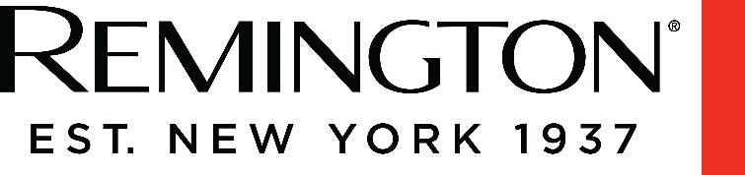
Press Release 11th October 2022

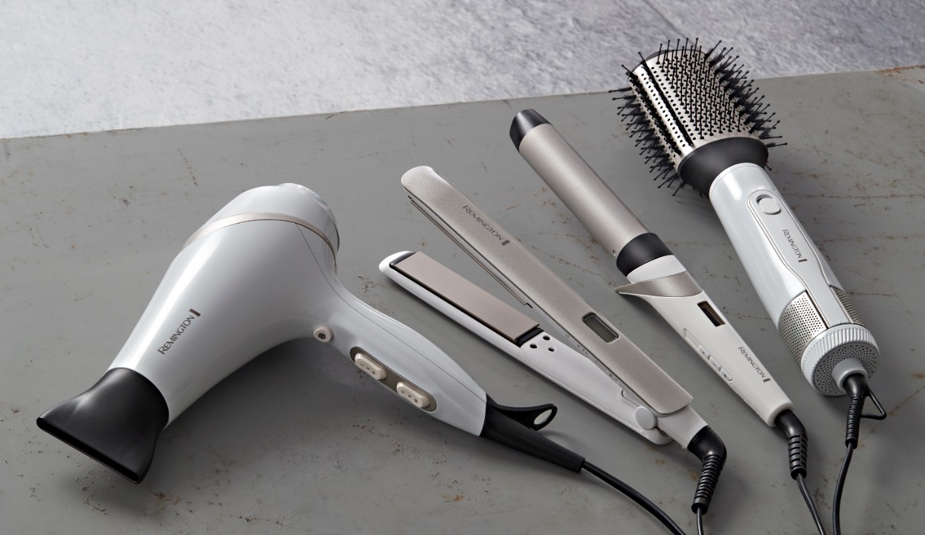
Achieve Salon Worthy Styles at Home this Festive Season with the Hydraluxe Range from Remington

Each year it seems to arrive earlier, but for many of us our diaries are already starting to fill up. A jam-packed schedule may mean visits to the salon are out of the question but with the Hydraluxe range from Remington, you can achieve that bouncy blow dry or super- sleek do from the comfort of your own home and with minimal damage.
The Hydraluxe range features a hairdryer, curling wand, straightener and volumising air styler, so you can achieve a whole range of looks whether it be sleek and straight, tousled beachy waves or voluminous Hollywood glamour. Helping to take the guilt out of styling, the range also uses a Hydracare Temperature Setting to allow for salon-worthy styling at a lower temperature.
Hydraluxe Straightener (€59.99)
Using its Moisture Lock Coated Plates, the Hydraluxe straightener helps take care of your hair whilst you style bringing together beautiful results and healthy styling. With built-in micro-conditioners preserving the hair’s perfect balance of moisture, you can produce beautiful, sleek styles without worrying about the damage of excess heat on your hair.
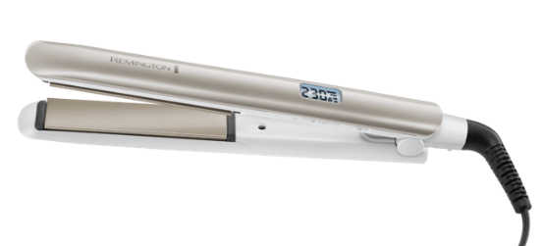
The Hydracare Temperature Setting also allows you to style at a lower temperature of 185ºC, meaning you can craft a sleek, smooth style or create the perfect curls without the worry of excessive heat damage. While working to keep your hair feeling healthy, the Ionic Conditioning in the slim, floating plates contains 90% more ions* that leave hair frizz free and with a glossy, lustrous shine.

Hydraluxe Volumising Air Styler (€39.99 RRP)
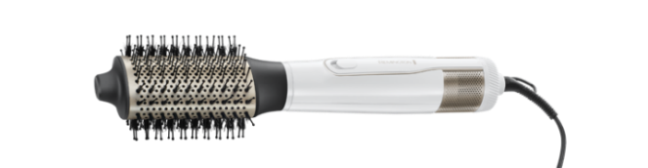
Creating that enviable bouncy blow-dry at home no longer has to leave you worried about excessive heat damage, as the Hydraluxe Volumising Air Styler provides salon-worthy volume that maintains your hair’s moisture levels. Using the Specialised Oval Barrel that allows you to get close to the root and Combination Bristles that lift the hair, you’ll be able to reach new heights with your blow dry, whilst the Air Styler’s Moisture Lock Ceramic Coated Barrel transfers smoothing Micro-Conditioners onto the hair as you style. With 3 Heat and 2 Speed Settings to choose from, the Volumising Air Styler allows you to personalise your blow-dry, tailoring the experience perfectly to your hair type, and setting your new bounce in place with the Cool Shot feature.

Hydraluxe AC Hairdryer (€59.99 RRP)
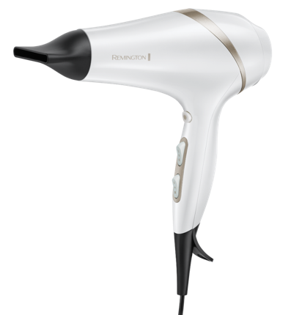
With its innovative Moisture Lock Conditioning Technology, the Hydraluxe AC Hairdryer means you no longer have to choose between styling or air drying, when looking to keep your hair feeling nourished and healthy. Micro-conditioners are released into the powerful 2300W airflow, forming a protective barrier to preserve your hair’s perfect balance of moisture whilst the Hydracare Temperature Setting styles hair at a lower temperature, evenly distributing heat through the Ceramic Grille to protect hair from excessive high temperatures. Perfect for a number of looks such as sleek and smooth tresses, a bouncy blow dry or even just blasting your hair dry, every styling need is covered thanks to the Hydraluxe AC Hairdryer’s three attachments as well as 3 heat and 2 speed controls that allow you to choose the settings best suited to your hair type.
Hydraluxe 32mm Wand (€44.99 RRP)
With the Hydraluxe 32mm Wand, you can create beautiful, healthy looking, shiny curls without the worry of excessive heat damage, as the Moisture Lock Ceramic Coated Barrel works to preserve the hair’s perfect balance of moisture, with its anti-slip ceramic coating transferring nourishing micro-conditioners to your hair as you style.
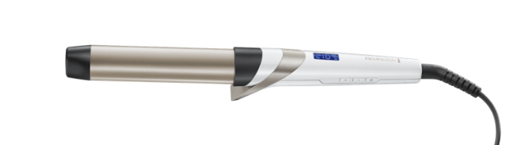
The anti-slip coating gives you a failsafe way to achieve those coveted beachy-style relaxed waves, stopping hair from sliding off the barrel so you can focus on creating your style. Crafting the perfect curls shouldn’t have to take all day, and the Hydraluxe 32mm Wand’s fast heat up function means your styling tool will be ready to use in 30 seconds, heating up to a range of temperatures from 160 – 210°C, including a Hydracare Temperature Setting of 185°C for healthier styling.

Available from independent Irish electrical retailers and pharmacies nationwide.

For press enquiries, please contact Maedhbh Caulfield, maedhbh@revolve.ie Tel: + 353 1 284 1944
Revolve Marketing & PR, 23/24 The Crescent, Monkstown, Co. Dublin, Ireland, A94 X960 .

-ENDS-

Notes To Editor
About Remington
As a division of Spectrum Brands Holdings powered by innovation, Remington has been helping the world get ready for over 80 years. We pride ourselves on being at the very cutting-edge of technology and work with top salon professionals from all over the world to produce electrical personal care products that really work, care for you and deliver superior results every single time.
To find out more about Remington or the Hydraluxe range, visit: https://uk.remington-europe.com/collections/hydraluxe-collection
*Vs a standard Remington straightener

