Press Release 17th May 2022
Achieve Silky-Smooth Summer Skin at Home with a Ladies Hair Removal Tool from Remington
With Summer BBQ’s, Festivals and Sun Holidays on the Horizon, many of us are looking at how best to achieve silky-smooth, hairless limbs. Whether you prefer shaving or epilating, having the right tools is half the battle, Remington’s range of Ladies’ Hair Removal Tools delivers incredible results every time from the comfort of your own home.

EP5 5-in-1 Epilator RRP €59.99
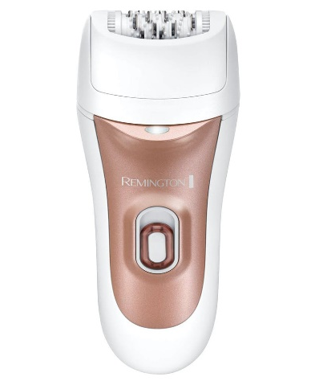
Helping you enjoy up to four hair-free weeks, the EP5 5-in-1 Epilator also offers faster performance, removing 60% more hairs from the root in one pass. The precision light helps you to see every hair, meaning there’s less chance of missing any during use.
Hair removal shouldn’t be uncomfortable, so with the epilator’s 40 comfort tweezers, you can capture even the finest hairs with ease. Five different attachments allow you to choose the right one for you, including the Ultimate Contour Cap, a Detail Cap for smaller areas and a Shaver Head with Bikini Comb. There’s even a Massage Cap with Aloe Vera for the gentlest hair removal.
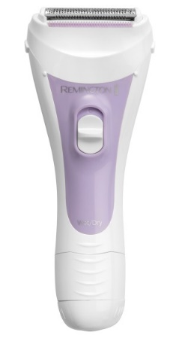

Wet and Dry Shaver RRP €21.99
The cordless Remington Wet and Dry Shaver is designed to provide a simple and smooth shaving experience for every woman. The double-sided intercept trimmer with single foil captures hair effectively, giving you a close, comfortable shave. Improved cutting performance gives you 2 x smoother results, while aloe vera moisture strip soothes skin against irritation. As the Wet and Dry Shaver can also be used in the shower, you can shave time off your beauty routine too.

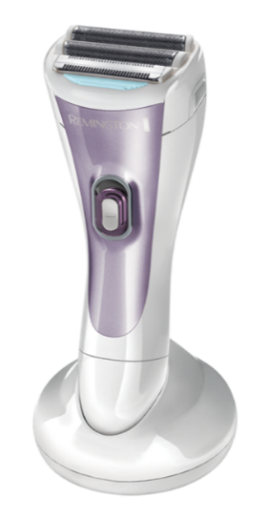
Cordless Double Foil Shaver RRP €39.99
Get ready for a soft, skin-loving result with this fast, instant hair removal that won’t leave skin red or irritated after shaving. The Cordless Lady Shaver features two hypoallergenic floating foils which comfortably follow the body’s contours so even hard to reach places can be tackled gently and effectively, ensuring that you get an exceptionally close and comfortable shave.
An integrated flexible trimmer captures the finest hairs – even those stray ones that can sometimes escape. It also comes with a handy bikini attachment so you can gently and precisely trim intimate areas. With a 30-minute usage time, this shower-proof shaver has been ergonomically designed with anti-slip grip which means you can use it in the bath or shower with confidence.

Remington’s Top Hair Removal Tips
- Exfoliate - ingrown hairs can develop when shaving and exfoliating also helps keep your skin looking better and prepared for a tan (natural or not).
- Have a bath or shower - softens your skin and hair follicles making it easier to shave.
- Take your time - so you don't miss any spots.
- Moisturise - the Remington cordless lady shaver is Aloe Vera infused which helps minimise any dry patches.

Available from independent Irish electrical retailers and pharmacies nationwide.

For press enquiries, please contact Katie Stafford Noonan, katie@revolve.ie, 087 9073791.
Revolve Marketing & PR, 23/24 The Crescent, Monkstown, Co. Dublin, Ireland, A94 X960 .
-ENDS-

Notes To Editor
About Remington
As a division of Spectrum Brands Holdings powered by innovation, Remington has been helping the world get ready for over 80 years. We pride ourselves on being at the very cutting-edge of technology and work with top salon professionals from all over the world to produce electrical personal care products that really work, care for you and deliver superior results every single time.

