Press Release 13th June, 2022
Last-Minute Father’s Day Gifts for the Main Man in your Life from George Foreman
A gift that reflects your Father’s passion is a touching way to show him how much you care and if there is a passion that seems to be shared by fathers around the globe it’s grilling and barbequing. If the father in your life is an avid cook, host or simply loves food, The George Foreman range creates flavoursome and exciting dishes for everyday meals and dinner parties and makes a perfect Father’s Day Gift.

Smokeless Grill RRP - $€$129.99
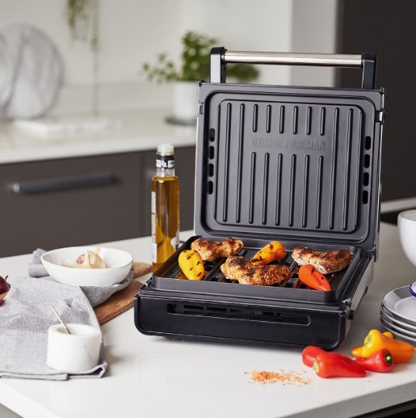
If your Dad manages to leave a smoke-filled room every time he cooks, the George Foreman’s Smokeless Grill (RRP $€$129.99) will be a game changer. This versatile grill is designed to bring Smokeless Contact Grilling for up to 87% Less Smoke*, so you can prepare nutritious grilled food without any lingering greasy smells or a smoke-filled room. With Smokeless Technology, the hot cooking juices are quickly directed through holes in the grill plate and immediately cooled, preventing them from burning onto the grill, which helps to eliminate smoke. The Integrated Venting System helps to keep the unit cool so that it doesn’t overheat and prevents any fat on the drip tray or grill plate burning to help eliminate greasy smells.
Updated with a new premium look and feel, the smokeless grill comes in a stainless-steel finish, guaranteed to make a style statement in any kitchen. Cleaning your Smokeless Grill has never been easier. With an Advanced Non-Stick Coating, you can simply wipe the plates with a damp sponge or cloth, for effortless cleaning. The Removable Plates and Drip Tray are also Dishwasher Safe and 3X More Durable**so you can easily pop them in the dishwasher without the coating wearing away.

Fit Grill RRP - €29.99 (S), €52.99 (M) and €84.99 (M)
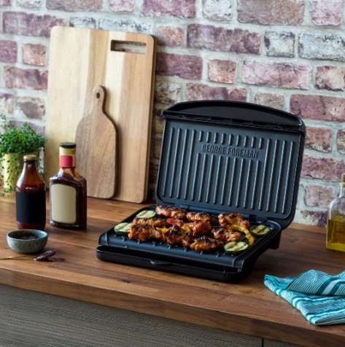
The Fit Grill Collection transforms cooking experiences by reducing prep time, making it easier to create healthy dishes at home. The Collection is designed to fit into your everyday life; it’s small, light, and easy to clean – without compromising on premium grilling performance. Available in three sizes (S €29.99, M €52.99 and L €84.99 RRP), the collection offers vertical storage and brilliant cooking results, but with 30% reduction in footprint and 160% faster heat up speed. The fit grill collection offers a healthy way to prepare a variety of tasty, low-calorie meals, while preserving every bit of delicious flavour. With an improved non-stick grill coating, the Fit Grill distributes heat evenly, ensuring superior cooking results and precise grilling, every time. And with angled grilling plates and a built-in drip tray, they reduce fat to support a balanced diet.

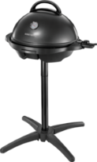
Indoor/Outdoor Grill RRP - €139.99
With a sturdy removable grill stand, perfect for the patio, the Indoor/Outdoor Grill (RRP €139.99) has room for over 15 servings of delicious meats, veggies, kebabs, desserts, and more! The BBQ grill is easily removed from the base and can be safely operated for some countertop grilling indoors.
The Indoor/Outdoor Grill’s non-stick coating and proprietary fat-removing slope (which removes up to 42% of fat from traditional BBQ foods) mean it is durable, easy to clean, and removes the need for butter and oil. Ensuring perfect results every time, the temperature probe at the side of the grill lets you choose from five heat settings giving you complete control over the speed and intensity your food is cooked at.
George Foreman’s Indoor/Outdoor Grill is apartment approved, kitchen ready and will ensure your BBQ Plans come to fruition, no matter what the Irish weather has in store.

The George Foreman range is available from independent electrical retailers nationwide.

For press enquiries, please contact Jessica Ryan, jessica@revolve.ie. (01) 284 1944. Revolve Marketing & PR, 23/24 The Crescent, Monkstown, Co. Dublin, Ireland, A94 X960.

-ENDS-

Notes to Editor

George Foreman has been the number one brand for portable electrically heated grills since 1994. The George Forman grill brand is synonymous with healthy, low-fat, flexible at-home cooking.

*vs George Foreman Classic Grill 24330/56 when grilling 20% fat content beef burgers (113g) with a clean grill and drip tray

**Compared to standard George Tough TM non-stick coating

