Press Release 6th March 2022

Timeless Pieces that Adapt to Your Lifestyle – Luxury Leather Accessories from My Name is Ted are the Perfect Gift for Mother’s Day
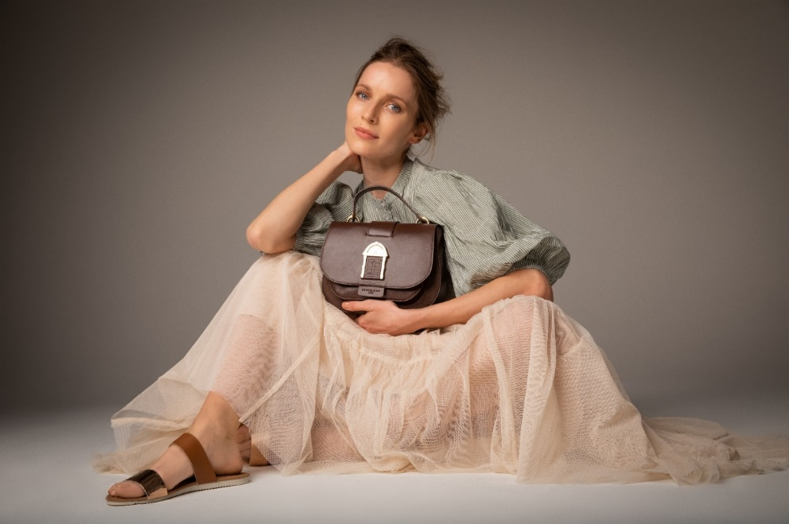

Many of us will have looked back as adults and wondered how our mothers managed to do everything seemingly at once, putting everyone else’s needs ahead of their own. If you are looking to treat the Mother’s in your life this Mothers’ Day with a luxury gift that she will love, My Name is Ted has the perfect range of Luxury Leather Accessories that are a Fusion of Timeless Designs and Modern functionality.
Family is at the core of My Name is TED, which was founded by the grandson of Ted Carbery who crafted leather accessories in Ireland in the 1950s using his mouth. A Father of 11, saddler Ted Carbery was born in Mountmellick, Co. Laois in November 1912. By the 1940s, 44 year old Ted had built a thriving business with two leather workshops but suffered an aneurysm which resulted in the loss of his memory, speech and use of his right-hand side. Despite this, Ted’s road to recovery lasted 3 years, during which time he relearned and adapted his craft continuing to create leather pieces that served his community for the rest of his life.

Each leather accessory is designed to last a uncompromising luxury that can be worn daily. A Door Bag or Handysan is a Mother’s Day gift that can be enjoyed for years, and even generations to come.
Handcrafted using the finest quality leather, the Irish owned Company’s designs are as practical as they are stylish, inspired by life while redefining fashion with a purpose. Inspired by the times we live in and paying homage to the famous Georgian Door at No.7, Eccles Street, in James Joyce’s “Ulysses”, the standout feature of each bag also provides a function. The feature of each (The Door) functions (Opens & Closes) to give a feeling of security etc. (of security behind your door, a memory of a special door from your childhood or a time in your life).
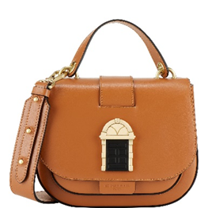
Cross Body Door Bag, RRP €595.00
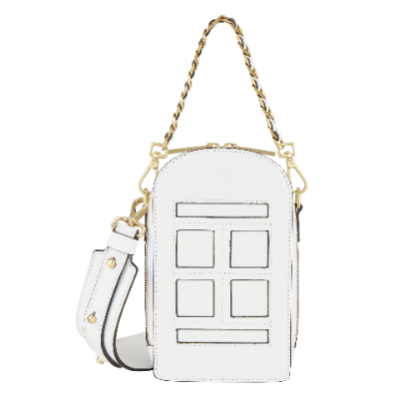
Hand-crafted from 100% Full Grain Italian Leather with Solid Brass hardware, the classically shaped Door Bag is the perfect Cross Body Bag. A staple in every woman’s closet, the bags’ wide shoulder strap with adjustable rivet makes for a comfortable wear with ample space for your everyday items in its interior spaces, luxuriously lined with Italian Suede. With a range of Colour Combinations available, which one is perfect for your Mum?
Cross Body Door Bag in Tan €495

Mini Door Bag, RRP €495.00
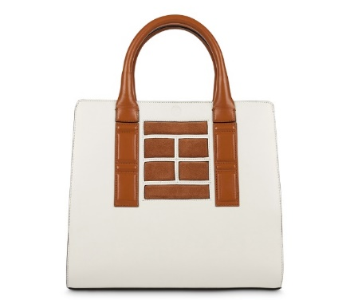
City break or Cocktails, The Mini Door bag is the perfect size for all your essentials. Its unique and instantly recognisable vertical shape emulating a Georgian Door, features dual all- round zips for ease of access with integrated credit card slots in the front panel of the bag. Designed in Ireland and ethically and sustainably handcrafted in Italy using 100% Full Grain Italian Leather, the Mini Door bag is available in a range of colours and finishes.
Mini Door Bag in White, €495
Door Bag Tote, RRP €695.00
Because being a Mum, means you need to be prepared for all eventualities but shouldn’t mean utilitarian. With My Name is TED’s signature Georgian Door design blending from bag to handle, the Door Tote Bag is a timeless statement piece with enough space to carry laptops, books, children’s toys and more. Handcrafted from Italian leather and finished with Solid Brass Hardware, the Door Tote is available in a range of colour combinations and is perfect for the on-the-go-Mum.
Door Bag Tote in Champagne, €695
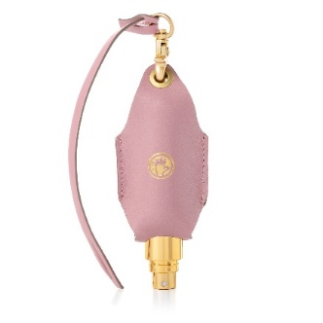
Handysan, RRP €69.00
Hand sanitizer has become a permanent staple in our handbags and the HandySan leather carry case for hand sanitisers is designed to help make keeping safe feel a little more luxurious. Available in 10 shades, the adaptable luxury leather carry case for hand sanitisers is made using recycled materials and fits all shapes and sizes of 50ml bottles. With the attached keyring designed to clip onto your bag, belt or car keys this stylish companion eliminates the need to search or dig for your sanitiser!
Handysan in Dusty Pink, €69

My name is Ted is Available Online at www.mynameisted.ie

-ENDS-

For press or interview enquiries, please contact Katie Stafford Noonan, katie@revolve.ie
M: +353 87 907 3791 L: +353 1 284 1944
Revolve Marketing & PR, 23 The Crescent, Monkstown, Co. Dublin, Ireland, A94 X960

Notes to Editor
- Irish owned, award-winning business that creates luxurious lifestyle leather bags and accessories inspired by life including HandySan, wallets and purses. Based in Mullingar, the collection features unique bags, wallets and purses that are designed in Ireland and handmade in Italy using only the finest Italian leather with luxurious lining and solid brass hardware and presented in a custom-made sustainable box with free delivery in Ireland.

- Retail plans for 2022/23 are well under way here in Ireland as well as expansion into the US Market with the support of Enterprise Ireland.

- The Door Bag Collection, which was part of CREATE 2020/21 at Brown Thomas, which showcases 31 incredible designers and the very best and brightest in Irish design. Brown Thomas’ CREATE continues to nurture new talent and Ireland’s dynamic design community more than ever. With the reinvention of retail and sustainability being at the core of Brown Thomas’ business, they were pushing for progression. CREATE showcases brands on the platform of luxury, designer department store, sitting alongside international brands and being elevated to that level. It gave My Name is Ted the opportunity of customer feedback.

- The fascinating story of Ted Carbery using his mouth and left hand in the 1950s to make leather bags and accessories inspired Brendan McEvoy, Ted’s grandson and his wife Kasia to bring the family tradition and brand back to life. Studying the intricacies of Ted’s work, in 2018 the husband-and-wife team set out to create a range of luxury leather bags and accessories inspired by life-combining ultimate practicality with uncompromising luxury standards.

- Award-winning and unique luxury leather goods are designed in Ireland and handcrafted in Italy using the finest Italian leather and solid brass hardware. My Name is TED has been a fast favourite with top personalities e.g., Angela Scanlon, Laura Whitmore, and respected by a community of happy customers around the world.

- Designed in Ireland and manufactured in Italy.

- The Door Bag Collection pays homage to perhaps the most famous door on Eccles Street, No.7 the home of Leopold Bloom the central character in James Joyce’s renowned novel “Ulysses”.

- Inspired by real life stories.

- Interview opportunities are available upon request.

Keep up to date with My Name is TED on Social Media and See How other Mums are Styling their Accessories

@tedbags Facebook.com/tedbags @tedbagz

